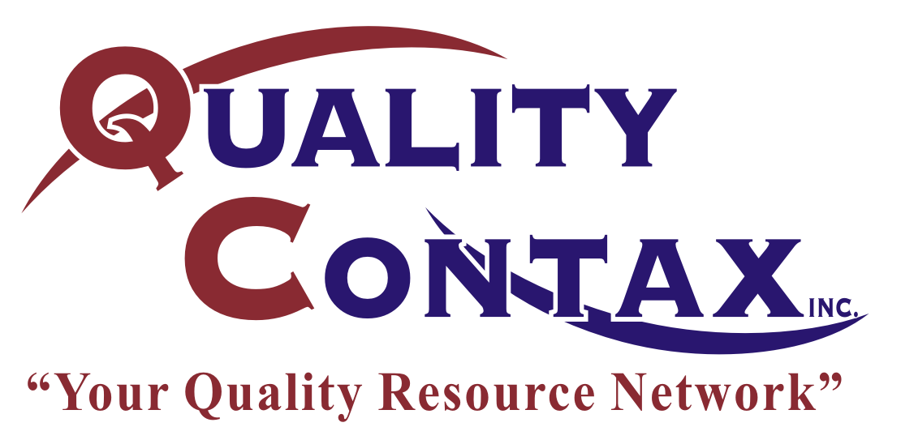

CONSENT TO DRUG SCREENING
And
POLICY RECEIPT ACKNOWLEDGMENT

I hereby consent and agree to give a sample of my urine and/or blood for drug/alcohol abuse screening at the request of Quality Contax Inc. and all its affiliates and clients.

I authorize Quality Contax Inc. and its affiliates, clients, or any hospital, clinic, or laboratory conducting or analyzing my drug/alcohol screening to release information to each other and furnish results of the screening among themselves.

I agree to release and hold harmless Quality Contax Inc. and all its affiliates, clients, any hospital, any clinic and any laboratory from any claim, action, or liability that might arise out of the drug/alcohol abuse screening or the disclosure of screening results.

I understand that Quality Contax Inc. may terminate my employment if drug test results are positive.

I have read this Consent to Drug Screening and Policy Receipt Acknowledgment and I understand and accept all of its terms.

Agreed to and accepted:

Signature

Print your name

Date

Social Security Number

Zip code you want to use for nearest screening location

